CO4-AT1-Industry Based Question
Question – 1:
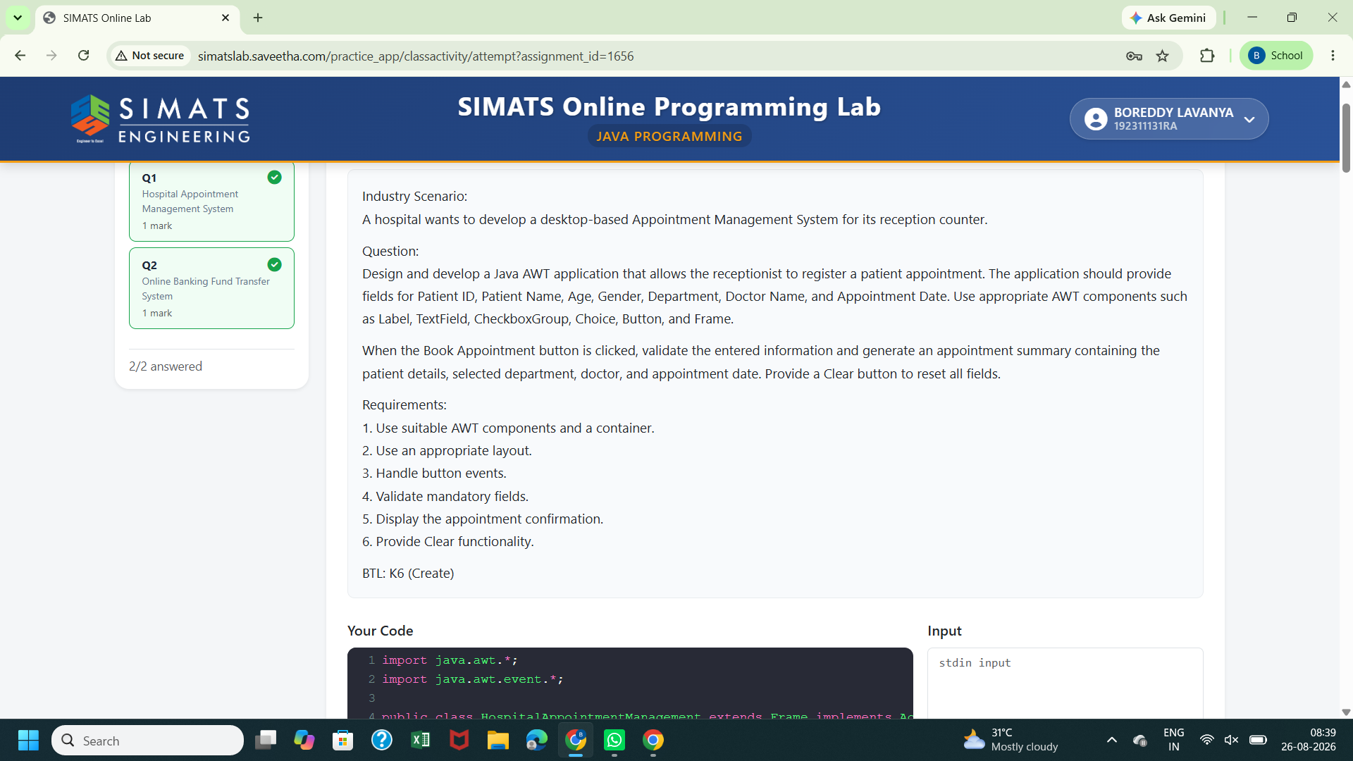
Question – 2:
